What Is People Analytics? Definition, Process, Trends, and Tools

What Is People Analytics?
People analytics can be defined as the deeply data-driven and goal-focused method of studying all people processes, functions, challenges, and opportunities at work to elevate these systems and achieve sustainable business success.
People analytics is often referred to as talent analytics or HR analytics as well. Essentially, gathering and assessing people analytics leads to better decision-making through the application of statistics and other data interpretation techniques.
Smarter, more strategic, and data-backed talent decisions are thus closer at hand, and this is applicable throughout the employee lifecycle – from making better hiring decisions and more effective performance management to better retention.
People analytics has evolved considerably from when it was first used in organizations in the mid-1900s. There has been a clear transition from prescriptive analytics to predictive analytics, with which organizations can now be better prepared to face the dynamism of their operational environment and be proactive rather than reactive. For example, sophisticated data science, interactive data visualization, and machine learning – all integral parts of people analytics today – were nowhere a part of the process until a few decades ago.

The Process of People Analytics
People analytics today is a lot more intuitive and predictive. With that expectation to live up to, the process involves the following steps.
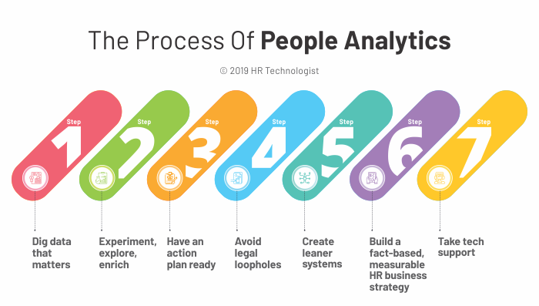

Step 1: Dig data that matters
The core question to ask here is, “What data is relevant to our business goals?”
and to set the key performance indicators (KPIs) accordingly. This allows you to save major resources by only investigating areas that need direct monitoring, such as operational tasks within the people management spectrum, and can lead to tangible business success.
If it does not add strategic value, digging that data could be a waste of time. Knowing what to focus on also helps in applying the right statistics, data mining, machine learning, survey management, and strategic workforce management tools.
Learn More: 5 Key Learning Management System (LMS) Trends in 2019

Step 2: Experiment, explore, enrich
In a crowded and visibly fragmented market, it is imperative to choose a people analytics tool by exploring the market, experimenting with different options, and analyzing which option would enrich the organization the most. Multiple offerings include data mining, data transformation, and data visualization techniques, all merged into a user-friendly self-service interface.
Platforms that offer a wide range of features often require a lot of manual manipulation to access important data, and these aspects can be tested only through systematic experimentation.

Step 3: Have an action plan ready
Once you know what your end goal is, which data is relevant, and what the available options are (based on clear pros vs. cons analysis), create an action plan. Applying big data and predictive analytics to talent management, leadership development, and organizational capabilities often helps in fine-tuning the action plan.
Moreover, having a well-defined plan of action enables a better understanding of why certain changes may be taking place and where the organization is headed and can thus help garner more stakeholder support.

Step 4: Avoid legal loopholes
Ensuring that legal compliance is maintained in the collection of all data is crucial. Before you start on the analytics project, have a legal team validate the data sourcing techniques and processes. It does not end here.
Once the raw data has been gathered and treated, the results gleaned need to be approved as well before they can be applied or published. In our digital ecosystem, with data protection and privacy laws still evolving, it is prudent to keep abreast of the changes and double-check on legal compliance.

Step 5: Create leaner systems
Irrespective of the complexity of the project at hand, the broader strategy that the processes must adhere to needs to be simple and lean. The basic process of data analysis and interpretation should allow for easy application, updating, and readability.
For example, create the basic outline simplified as intake and design (data collection and the design of the analysis), data cleaning (removing irrelevant or unreliable data), data analysis (quantitative and qualitative exploration), and sharing insights (interpretation and presentation of the data). This can help avoid unnecessary complications such as confusion about the flow of steps involved, time wastage, or repetition of sub-processes that occur with unstandardized process structures, while still allowing room for tweaks where necessary.
The idea is to find the right balance between the limited moving parts (people and the dynamism of the environment) and fluid, customizable systems and processes of people analytics. When you have the right team with the relevant skillset in place, it is easier to streamline the whole process and apply quality controls.

Step 6: Build a fact-based, measurable HR business strategy
A realistic HR business strategy avoids functional silos and can align talent to business seamlessly. Having clear KPIs and ROI expectations from people analytics endeavors ensures that the impact is measured often and with transparency. A winning strategy needs to be backed by data and an effective plan of action.

Step 7: Take tech support
Technology is interspersed with every aspect of life today and more so with processes like people analytics, where often a bulk of analytical data is to be treated with little or no room for error. New-age HR tech tools make real-time data easily accessible. And this is an opportunity that needs to be milked because today, agility and real-time intelligence can truly set you apart from the competition.

Four Key People Analytics Trends
Since people analytics relies heavily on evolving data-mining technologies and data-interpretation strategies, the trends around people analytics develop in time to the same. Here are the top 4 trends that are shaping people analytics in itself and how it interacts with the business. Some trends work in a dual loop – they affect people analytics and in turn, all other aspects of HR.
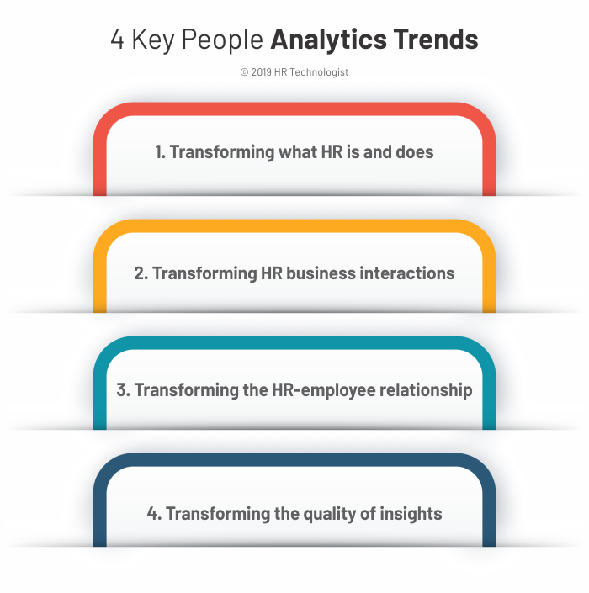

1. Transforming what HR is and does
Bersin research points out that a meager 2% of HR organizations have mature people analytics competence to bank on. There is thus quite a heavy first-mover advantage for innovative, intelligent organizations that are trying to tap into this space.
With people analytics changing how recruitment is conducted, how performance is measured, how compensation is planned or growth is mapped, and how learning and retention can be managed better, people analytics is quickly changing how HR operates.
According to recent studies by Deloitte, increasing job offer acceptance rates, reducing HR help tickets, and optimizing compensation are just a few ways in which people analytics is quickly becoming the new currency of HR. Moreover, with HR processes evolving to keep pace with business needs, people analytics is moving from being a one-time initiative to becoming a real-time, easily modifiable tool that HR has immense benefits to draw from.

2. Transforming HR business interactions
With recent trends in the work ecosystem, the interaction between HR and business stakeholders (both internal and external) has been undergoing a transformation as well. People analytics needs to change in keeping with the latest trends in leadership. More transparency is a key trend emerging here, and intelligent insight is the need of the hour.
Businesses today need to be able to make sense of seemingly unrelated data streams and find meaning, correlation, and maybe even interdependence between one or more factors to predict and manage work better. People analytics has the potential to provide actionable recommendations to enable strategic planning and execution processes.

3. Transforming the HR-employee relationship
Employee expectations today are consumer-grade. People analytics is providing organizations with the ramp to upgrade the employee experience. Every interaction that a candidate or an employee has with an organization is a data point and could be utilized to glean interesting insights. The idea is the need to transform the relationship that the HR has with employees – to help HR become and be perceived as more than just a support function.

4. Transforming the quality of insights
The quality of insights that are expected on a daily basis has changed over the course of the last couple of years. People analytics can live up to these expectations if you focus on two key aspects: analytics literacy and data security.
More employees will need to become analytics literate to decrease dependence on technical staff and to allow more perspectives to flourish. As people analytics becomes a staple at organizations, data integrity and data security will need to be upgraded and maintained for all listening channels and pulse checks.
We discussed legal compliance, but data security should ideally go deeper than that and become a cultural trait within the organization rather than being superficial check just for the sake of being compliant.

Three Key Level-based Checks to Choose the Right People Analytics Tools
With a vast array of available vendors, options, and subscription plans, choosing the right people analytics tools can often seem like a rather daunting task. Here’s a three-level need-based check to make the right decision.

Level 1: A working HR dashboard
To get started with people analytics, use a basic dashboard that allows you to capture, aggregate, and visualize data.
Tools like Power BI, Tableau, and Qlik allow ease of use and ease of data access. With a level 1 requirement, your priority should be to keep your people analytics system as simple as possible.

Level 2: An insightful HR dashboard
You may have a steady dose of relevant data and need basic insights to analyze better and make stronger decisions. Statistical tools like Excel or SPSS are effective as well, though they may not come with quirky visual aids and social-media style interfaces. Tools like Visier, while taking some time to be set up, come with holistic analytics solutions.

Level 3: A predictive HR dashboard
Your organization is at the third requirement level when you seek not only to analyze data but also to make intuitive predictions based on upcoming trends. These tools help you study behavior in a way that you can predict the next course of action.
For example, there might be some correlation between your employees updating their LinkedIn page, taking frequent leaves, and with them not being very content at work. While this is a very simplistic situation, predictive tools could help you make connections with behavior and decision patterns that you might have missed otherwise.
Python or RStudio can help with advanced analyses for large quantities of data, though they might require you to hire data scientists specialized in the field.

Update, Upgrade, and Upskill for Smarter People Analytics
With the latest people analytics and workforce analytics solutions, you can delve deeper into the behavioral aspects of work, understand the cause-effect relationship between different human and non-human aspects at work, and make better decisions.
The three points to remember are to know what data you need to quantify and qualify, to understand what the latest trends are, and to know what your end goals are. Enabling your HR to update, upgrade, and upskill their knowledge and capabilities will ensure that your organization optimizes the latest people analytics offers and can ride the latest trend waves towards a smarter, happier workforce.

