Core Competencies

Core Competencies Explained
When starting a job search you should be aware of core competencies and how employers use them to determine your suitability for a particular role. In essence, core competencies are a group of skills or attributes that employees need to carry out their work effectively.
Competencies can vary between different industries and levels of seniority, though the majority are found across many industries. They are often sprinkled throughout job descriptions and person specifications. As part of your application you will need to demonstrate how you meet each of the core competencies identified by the employer. This guide outlines the most popular competencies that you will come across during your job search.

People Management
Managing people is usually a competency reserved for supervisory or managerial roles but it can also be expected of junior staff. Being able to manage employees may form a significant part of your role. It is therefore important that you can demonstrate superior people management skills.

1. Training and Development
This core competency can range from identifying training and development opportunities through to helping individual employees update their knowledge of emerging technologies. It can also involve skills development, so that employees can go for promotions or increase their responsibilities.
In a number of roles, employers will want to see that you are committed to developing your skills and you are willing to participate in training and development.
Examples include:
- Pro-actively identifying training opportunities
- Developing your employees' skills through relevant assignments

2. Managing Performance
This is a continuous process which involves making sure that employee performance contributes to the goals of the department and the wider business. This competency may be included in the person specification.
Within your application, you should demonstrate how you help the organisation achieve its goals, how you maintain high standards, what you do when performance problems arise and how you develop your own performance through training or shadowing.
Examples include:
- Setting clear, measurable performance goals
- Finding solutions to problems that may impact your performance

3. Coaching and Mentoring
In certain roles, particularly technical jobs in IT or programming, you may be expected to provide coaching and mentor junior staff. Managers should also possess these skills.
In your application you should be able to demonstrate how you have worked with colleagues or partners to offer coaching and mentoring to improve their practice, enhance their skills or advance their knowledge. It takes a certain aptitude to coach and mentor staff, so you must be able to convey how you have used this skill in the past and how you can relate it to the role you are applying for.
Examples include:
- Sharing your expertise with others
- Listening and responding to questions effectively

4. Team Building
Employers need to know that you can work collaboratively as part of a team to meet defined objectives. People who possess this competency will encourage information sharing and partnership working, and actively encourage others to participate in the decision making process.
Team building is important at every level within an organisation, not just at managerial level. Through your application and interview you should be able to demonstrate your ability to work across departments, help colleagues outside of your immediate working group and obtain feedback to see how colleagues could work together more cohesively.
Examples include:
- Responding constructively to others' ideas and suggestions
- Encouraging active participation and cooperation within the team

Team building is an important competency, whatever your seniority.

Personal Development
Personal development is a career-long process and is a way to regularly assess your skills and capabilities, consider your goals and maximise your potential. There are a number of ways in which you can improve your own development in the workplace, such as re-evaluating your time, conducting a skills appraisal, reviewing your transferable skills or overcoming any barriers to acquire a new skill.

5. Commitment to Excellence
Demonstrating a commitment to quality means that you take pride in your work and strive to deliver the best possible results. You should always be looking for opportunities to improve the way you work, generate ideas for streamlining processes and thoroughly check your work. Resilience, determination and innovation are all qualities that you should emphasise if this core competency is required.
Examples include:
- Fact-checking your work
- Actively seeking new ways of working to improve productivity

6. Mind Mapping and Structured Thinking
In certain careers, employees are required to deploy structured thinking skills and generate ‘mind maps’ (diagrams used to display connections between ideas or concepts). This could be either in a project-based role or a technical capacity. Setting out your ideas and thoughts in a logical pattern using mind maps is an essential skill in these types of roles.
Examples of this competency include:
- Using mind maps to display complex information
- Communicating specialist technical information clearly and concisely

7. Career Progression
Employers look favourably on employees who are committed to career progression and development. It shows that you are driven, committed and aim to deliver the very best that you can for the business. Career progression may appear in the form of promotions or can be as simple as being assigned more senior duties.
Examples include:
- Working to develop existing competencies to a higher level
- Actively seeking training opportunities that facilitate progression

Leadership
Leadership competencies help businesses determine which level of management requires certain skills. When selecting and developing management professionals, organisations should consider a candidate's competencies and compare these with the skills that need further development in order to succeed within a leadership role. Approaching leadership competencies in this manner can help businesses make accurate decisions about recruiting, developing and promoting the highest quality candidates.

8. Strategic Management
All businesses need to be managed effectively to succeed. A strategic management competency relates to the coordination of business operations to achieve and maintain an advantage over the competition. Strategic management is about reviewing multiple business areas and evaluating data, systems and processes to make informed decisions.
Examples include:
- Evaluating data to gain business insight
- The ability to analyse multiple processes and systems simultaneously

9. Future Planning
All successful managers need to be able to plan effectively. There will be a number of business areas which require careful planning from finance through to marketing and general operations. You will need to demonstrate your capacity to meticulously plan business activities and implement projects successfully.
Examples include:
- Identifying industry trends and developments in advance of planning
- Anticipating stumbling blocks and developing contingency plans

10. Persuading and Influencing Staff
As a manager you will be expected to influence and persuade a wide range of people in a variety of situations. This may include influencing budget managers to take greater control of their finances, or persuading a member of the team to change an approach or behaviour that is negatively impacting on performance.
If you want to effectively persuade and influence people in a business, you should clearly define what you expect, plan ahead and listen carefully to those you are communicating with.
Examples include:
- Using audience-specific language and examples to best illustrate your point
- Presenting multiple arguments in support of your position

11. Change Management
As a management professional there will be occasions where you will have to undergo a period of organisational change. This may relate to streamlining services, cutting budgets or improving performance. To drive change initiatives, you need to be receptive to change occurring within the workplace. You also need to demonstrate strong people skills and define a clear direction for the organisation so employees understand what is expected.
Examples include:
- Helping others to manage the emotional impact of change
- Embracing change and proposing more effective ways of working

Communication
In any business, communication skills are absolutely essential. Being able to share information verbally and in writing is an integral part of any position.

12. Commitment to Customer Excellence
Whether you are providing products or services, your customers should always be at the forefront of decisions and service delivery. Customer excellence involves responding to queries promptly, offering as much information as possible and providing products or services that customers value.
Examples include:
- Speedy and effective resolution of customer issues and complaints
- Adopting processes to track customer satisfaction

13. Collaborative Working
This involves establishing strong partnerships with fellow professionals and outside agencies. Being able to promote inter-departmental working and relationships with other organisations is essential in some roles such as healthcare. Collaborative working can involve a range of different aspects including networks, partnerships or alliances.
Examples include:
- Expressing an interest in others' experiences and ideas
- Working to build strong channels of communication with outside agencies/departments that may later be of assistance

14. Customer Relationship Management
Being able to manage your customer relationships is important. Customer refers to anyone who purchases your product or accesses your service. Promoting customer loyalty and delivering excellence are important qualities that employers look for.
Examples include:
- Communicating with customers to deliver a better service
- Ensuring interactions with customers are always polite and positive

15. Social and Emotional Learning
This competency is very important in industries such as education and welfare. It is the process through which you implement strategies to understand and effectively manage emotions to achieve a particular outcome.
Examples include:
- The ability to recognise and regulate your emotions and behaviours in the workplace
- The ability to recognise others’ emotions and perspectives and take them into account

16. Persuasive Techniques
In certain careers, you will be required to persuade people to adopt your way of thinking and initiate some kind of action. This may be changing a way of working or signing a contract. Persuasive techniques are very important in certain careers such as sales- or marketing-based roles, as well as for professionals who work in a managerial capacity.
Examples include:
- Successfully addressing key concerns and presenting mutually beneficial solutions
- Building successful relationships to ensure support during negotiations

17. Writing Skills
Being able to communicate clearly and concisely is an important skill for a number of reasons. You may be required to draft reports or prepare correspondence. Even communicating with fellow colleagues and partners is often achieved through email, so it’s important to be able to convey what you need to succinctly and effectively.
Examples include:
- Using concise, clear, appropriate language
- Structuring ideas clearly

18. Speaking and Listening Skills
Professionals must be able to communicate effectively when speaking to people. Demonstrating that you can communicate complex information to a non-technical audience is also valued by employers. In any verbal communication you should always ensure that you speak carefully and clearly so that you are easily understood.
Examples include:
- Speaking clearly and at a measured pace
- Maintaining eye contact to hold listeners' attention

Logical Reasoning
Sound reasoning skills are important. You need to be able to demonstrate that you are capable of considering all the facts, thinking them through intelligently to reach important decisions.

19. Making Decisions
Within many different roles you will be expected to make decisions - from prioritising your workload through to managerial decisions involving staff, working patterns or processes. To do so, you will need to deploy logical reasoning to assess the information that you have and make the best decision in the current situation.
Examples include:
- Analysing data and information to make considered decisions
- The ability to prioritise different business needs

20. Methodical Approach
Certain tasks in the workplace require a methodical approach, particularly those that are complex or involved. This may mean breaking the task down into more manageable segments or splitting the task between a team. Approaching a project methodically will produce better results than simply jumping straight in and trying to find an immediate solution.
Examples include:
- Breaking complex tasks into manageable segments
- The ability to identify possible problems or stumbling blocks

21. Identifying Patterns or Connections
Within many different roles, finding patterns, evaluating data and reaching conclusions is essential for the business. Positions such as marketing, business analysis and even general management all require candidates to demonstrate the ability to identify patterns. These could relate to performance, customer retention, sales or finance.
Examples include:
- Understanding the impact of specific data patterns and trends on the business
- Identifying inconsistencies in data and information

22. Research
Reviewing information, collating data and reaching informed decisions features significantly in many different roles. As a core competency it involves looking at data from a critical perspective, seeing the bigger picture and identifying gaps so that you can explore all possibilities.
Examples of this competency include:
- The ability to identify relevant sources of information
- Effectively using data and research to reach informed, effective decisions

23. Problem Solving
Solving problems is a fundamental skill that all employees should possess. It could range from something as simple as addressing a staff shortage through to something much more technical, such as overcoming a major stumbling block during the course of a project.
Examples include:
- The ability to identify the cause and effects of problems in the workplace
- Analysing existing information to come up with appropriate solutions

Transferable Competencies
While some of the above competencies relate to specific industries, there are several competencies which are ‘transferable’. This means that you can take them from one industry such as marketing and apply them in another such as IT.

24. Resourcefulness
Being resourceful is all about finding innovative ways to overcome obstacles or solve problems. It can also relate to finding ways to deal with unforeseen or challenging situations using the resources that you have available.
Examples include:
- Using existing information to devise new ways of working
- The ability to tackle unforeseen challenges using existing resources

25. Trustworthiness
In the workplace, honesty is a sign of trust. Colleagues and clients depend on your ability to make trustworthy decisions and provide an honest service. Being trustworthy can also relate to your ability to get things done without being constantly chased, or completing work without it being checked to ensure it is of the right standard.
Examples include:
- Communicating openly and honestly with colleagues and customers
- Taking personal responsibility for the quality and content of your work

26. Stress Reduction
Although a certain degree of stress in the workplace is normal, things can spiral out of control. Excessive stress can impact on many different areas, including your emotional health.
It is impossible to control everything in your working environment, but you should implement steps to reduce your stress levels. Being able to cope well under pressure and facing excessive amounts of stress are completely different things, so you need to be able to distinguish between the two and seek the support of a senior colleague if required.
Examples include:
- Responding calmly to criticism
- Proactively managing feelings or symptoms of stress

27. Moral Principles and Ethical Standards
Ethics are all about moral principles, or knowing the difference between right and wrong. They can also refer to behaviours and standards such as how you carry out your work and the way in which you handle certain situations.
Examples include:
- Taking responsibility for mistakes and errors in your work
- Respecting confidentiality agreements

28. Planning and Organisation
Being able to effectively plan and organise your workload is very important, particularly in careers such as law, finance and even marketing, as these are industries which are extremely deadline-driven. Planning is about coordinating your resources and budgets to meet deadlines or achieve targets.
Examples include:
- Using resources effectively to achieve objectives
- Prioritising your workload to ensure deadlines are met

29. Business Acumen
Employers want to see that you have an aptitude for business. This could be reflected in your knowledge, qualifications or achievements through your work or academic studies.
Examples include:
- Analysing competitors’ products and services to better understand your business position
- Understanding how industry trends impact on the business

Technical Competencies
Competencies in this category relate not only to computer skills but also to your ability to think creatively, devise innovative systems and processes and develop policies to facilitate operations.

Technical competencies are set to become ever more important to the graduate workforce.

30. Creative thinking
Developing innovative solutions and thinking creatively is important in a number of different sectors. It can relate to using mind mapping to brainstorm ideas or looking at something from a different perspective.
Examples include:
- Using existing knowledge to develop original ways of working
- Working with others to brainstorm original, mutually beneficial solutions

31. Technical Capabilities
The ability to identify how you can use systems and technology to improve ways of working. It may be implementing a new strategy for collecting customer data, or rolling out a system to collect performance data.
Examples include:
- Developing new solutions with existing technology
- Acting as a technical expert in a specific area/programme

32. Computer Literacy
In many industries you will be required to operate various computer systems and familiarise yourself with different software packages. This could range from the basic Microsoft Office to more complex computer software for roles such as accountancy or website design. Mastering certain computer skills is essential in certain roles.
Examples include:
- The ability to learn new systems quickly
- Experience of using a variety of relevant software packages

33. Data Management
This is important for collecting, managing and reporting data. It involves the capacity to use data to improve processes and operations while analysing results and presenting findings to others.
Examples include:
- Experience of checking all available data to get a more complete picture
- Using the data to propose effective solutions and identify potential risks

34. Equipment and Program Knowledge
If your role involves delivering technical support to customers, you need to acquire in-depth knowledge of equipment and programs. This not only allows you to deliver excellent customer service but to also diagnose and troubleshoot problems more quickly.
Examples include:
- Understanding how specific equipment and programs can benefit the business and its customers
- Ability to use existing knowledge to diagnose technical issues

35. Policies and Planning
Policy development establishes a foundation on which businesses build their culture and values. Consequently, understanding how policies are created and more importantly how to comply with them is an important competency that many employers will look for when recruiting new team members.
Examples include:
- Knowledge of how and why policy is important
- The ability to effectively communicate business values and culture
Any post that you apply for will usually incorporate several of the above competencies. If you can demonstrate how you apply each competency, drawing on past academic or work experience, there's every chance that you will succeed and go on to secure an interview.

An Infographic of These Competencies
The team at Intelligent Information liked this post so much, they created an infographic of it. We thought it would make a neat addition to this article, so we've included it here:
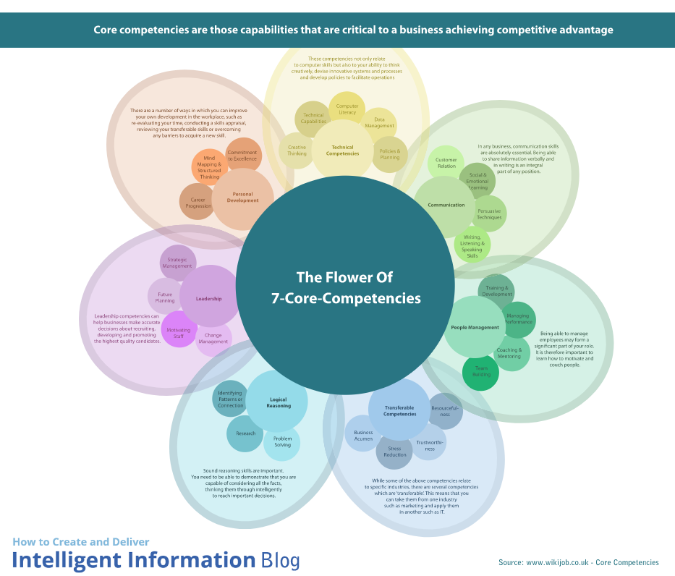

Further Information

